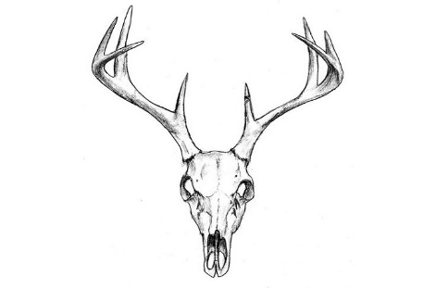
MELBY OUTDOORS
PRODUCTS AND SERVICES
14270 50TH ST NW
NEW LONDON MN 56273
320-354-5553
MELBYOUTDOORS.COM

SERVICE AGREEMENT
NAME: | PHONE:
COMPANY: | EMAIL:
ADDRESS: | LIC#:

QTY | SPECIES | CUSTOM  PROCESS | SOFT TAN | TAXIDERMY  WET TAN | TAXIDERMY  DRY TAN | EUROPEAN  SKULL | ANTLER  MOUNTS | TAG#
 | SIGNATURE: |  |  |  |  | DATE:
YOUR SIGNATURE STATES YOU ARE IN AGREEMENT WITH THE FOLLOWING:
Due to the many factors, such as primeness, general condition of the specimen, climatic conditions and most importantly the treatment in the field by the sportsman, we assume no responsibility nor can we guarantee the results of any dressed specimen. Melby Outdoors does not accept illegally taken wildlife. By using our services, you acknowledge each piece has been handled in the accordance with the laws of its states origin. You, by using our services, are legally stating that you are in compliance with the Federal Lacey Act (16 U.S.C. §§ 3371–3378)
WE ARE NOT RESPONSIBLE FOR ANY GOODS DAMAGED, DESTROYED, OR LOST DUE TO FIRE, THEFT, NATURAL CAUSES, ETC. PAYMENT IS DUE ON COMPLETION OF WORK. IF PAYMENT IS NOT RECEIVED WITHIN 60 DAYS THE ITEM WILL BE CONSIDERED THE PROPERTY OF MELBY OUTDOORS. ITEMS NOT PICKED UP WITHIN 60 DAYS OF NOTICE WILL BECOME THE PROPERTY OF MELBY OUTDOORS.

COMMENTS

